 | Chapter 16/Other Types of Local Stories

Lesson #16: The press walks a fine line between responsibly informing the public and pandering to its seemingly insatiable appetite for sensational crime news.

Crime/Accident/Fire Stories - most info comes from three sources:
- Police/fire/EMS officials & their reports
- Victim(s)
- Witness(es)

The circumstances of the crime will determine which source is the most important. Timing and the nature of the media outlet may also determine which source to approach first.

Check for the basic 5 Ws (and H):
- What happened
- Where did it occur
- Who was involved
- When did it happen
- Why did it happen
- How did it happen
- Injuries

Police reports are sometimes inaccurate (wrong spellings, wrong ages, and basic details). Don’t rely solely on official documents – editors demand multiple sources for every story!

Going to the scene: police or fire lines may be set up for public or operational safety, limiting a reporter’s access to the officials in charge.

Court Stories:
Most are likely follow-ups to earlier stories. There are two kinds.
- Criminal cases: the state charges someone with breaking a law
- Civil cases: an individual or company is sued for harming another individual or company

Libel – damage to a person’s reputation caused by a written statement that brings the person into hatred, contempt or ridicule, or that injures a person’s business or occupational pursuits; libel is similar to slander which is when someone says such damaging things out loud. [see handout]

Publication or broadcast of incorrect information may receive court protection from libel damages under a qualified privilege to make a fair and accurate report based on public records.

Court system:
There are two primary courts in America. Federal district courts have jurisdiction over cases involving violations of federal statutes, Constitutional issues, civil rights, etc. State Circuit or Superior courts have jurisdiction over cases involving state statutes (domestic relations, murder, civil cases, contract disputes, etc).

In New Hampshire there are:
- one U.S. Federal District Court (Concord)
- one U.S. Bankruptcy Court (Concord)
- District Courts (by town)
- Superior Courts (by county)
- State Supreme Court (for appeals of Superior Court cases)

Categories of crime:
- Felony – punishable by a fine, a prison sentence of more than a year, or death
- Misdemeanor – punishable by a fine or a county jail term not to exceed one year, or both

Felony cases can begin with a preliminary hearing or a grand jury indictment. Grand jury proceedings are usually secret.

The average person charged with a crime will:
- Be arrested (handcuffed, detained, booked, finger printed)
- Be arraigned (first court appearance where charges are presented; bail may be possible; no plea may be entered in felony cases)
- Appear at a probable cause hearing (where a judge decides if there is enough evidence to proceed with the case)
- Go to trial (or enter into a plea-bargain with prosecutors)

After a judge or jury renders a verdict, either side may appeal the verdict to the next highest court in the system.
Technicalities:
- Innocent till proven guilty – a basic tenet of criminal law in the U.S.; a defendant is not required to prove anything or even to testify
- Only a prosecutor, not a police officer, can file charges

Free-press/free-trial concerns:
Some lawyers feel journalists ignore the Sixth Amendment right of the accused to an impartial jury; the media claim that lawyers ignore the First Amendment right to a free press [p.349: references to Dr. Sam Sheppard & O.J. Simpson cases]

Change of venue: a judge moves a trial to a locality where publicity about the case is less intense

Gag order: when a judge issues a blanket order barring reporters from the courtroom and prohibits news coverage of a particular case. The USSUPCO has ruled gag orders are an unconstitutional prior restraint that violates the First Amendment. In each case the judge has to prove that a restraint order protects the rights of the accused and that no other alternatives would be less damaging to the First Amendment.

Courtroom cameras: from 1991-1994 the U.S. Judicial Conference experimented with TV cameras in federal courtrooms, after which it banned them. Cameras are permitted in some lower federal courts; 47 states allow some camera use in courtrooms.

Minority Rights/Race & Sexual Orientation:
- Journalists & judges both have a burden to protect the rights of the accused
- Some news outlets avoid mentions of race in crime stories
- Only when race is the central theme of a story should it be emphasized
- Most editors considers sexual orientation off limits unless it is the theme of the story

Other ethical issues:
- Media coverage of murder details
- Details of sex crimes or names of victims
- Defendant’s prior criminal record
- Confessions
- Names of juveniles charged with crimes

Obits are big business – newspapers & web sites sell advertising to funeral homes because readers frequently search them. Many newspapers handle them as paid advertising. Not just public figures deserve well-written obituaries!

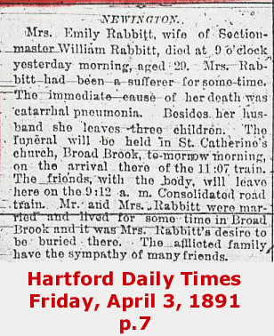 | 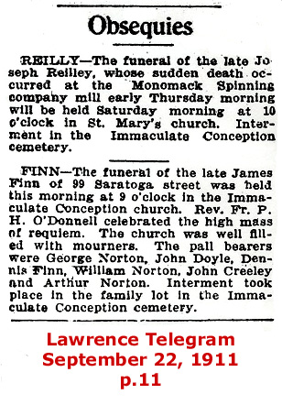

An obituary is a news story; utilize the same standards of crafting a lead and building the body as any other story:
- Who?  - What? | - Where?  - When? | - Why?  - How?

Obituary (o-bich’-oo-er-e) – a notice of a person’s death, usually with a brief biography (from Latin obitus, death)

Obsequy (ob’-si-kwe) – a funeral rite or ceremony (from Latin obsequium, compliance, service)

Death Notices – newspaper listings in abbreviated form, not full text

Life stories – what was important to the deceased? What is the evidence of that?

Newspaper policy often determines what will appear in print. Problem areas are:
- “in lieu of flowers”
- home addresses
- cause of death

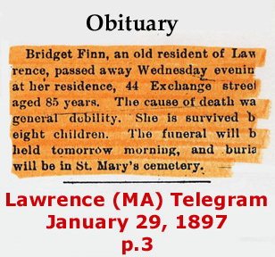  Capture the theme of the person’s life!  Sources of info include:  - Mortuary form  - Undertaker  - Paid funeral notices  - Newspaper morgue  - Family & friends  - Co-workers  Many good stories aren’t written because a reporter is afraid to do the reporting – ask family & friends for an interview! | 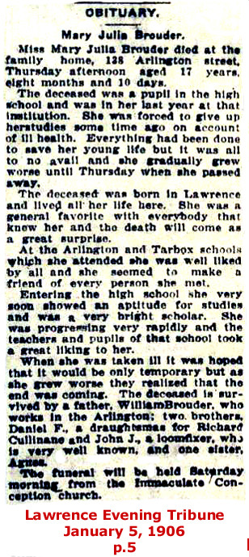

[p.361 policy on Death Certificates is debatable]
“If the person who dies is not a public figure and the family does not wish to divulge the cause of death, some newspapers will comply. That is questionable news judgement. The reader wants to know what caused the death…only if none of these sources will talk should the newspaper leave out the cause of death.”

“You can print the cause without the family’s consent, but you have to be certain it is correct, and the family is one of the few sources at deadline.”

“If the deceased was a public figure or a young person, most newspapers insist on the cause of death. If the death is the result of suicide or foul play, reporters can obtain the information from the police or the medical examiner.”

Embarrassing information – stigma related to AIDS, alcoholism, suicide; crucial factor is determining whether the deceased was a public or private person.

Choose your words:
- person dies “following” or “after” an operation, NOT “as a result of an operation”
- people die “unexpectedly,” NOT “suddenly”
- Catholics don’t “hold” mass; they “celebrate Mass”
- Reform Jews worship in temples; Orthodox Jews in synagogues
- Episcopal priests are “rectors” not “pastors”

