  CLASSROOM IN A BOOK® | Chapter 1  Audio Interfacing

Recording – the process of converting audio signals into digital data on a computer

Two domains of recording:
- analog – a type of recorded sound source that produces a sound wave similar to the original wave; all traditional methods of recording were analog (wax cylinders, record albums, all forms of tape)
- digital – translating a sound source into binary computer language

The device that performs these translations of electrical energy from one form to another is a sound card (in a computer) or an audio interface (in an external piece of hardware).

Both include analog-to-digital (A/D) and digital-to-analog (D/A) converters.

Software drivers handle communications between your computer and audio hardware.

Common Audio Interface Connectors (courtesy of Radio Shack):
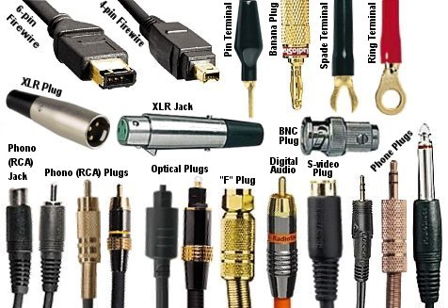
S
USB 2.0 Flash Drive (courtesy of Staples):  Universal Serial Bus is an industry standard developed in the mid-1990s that defines the cables, connectors and communications protocols used between computers and electronic devices. Version 2.0 has been the standard since late 2001. Version 3.0 was issued in January 2010. | 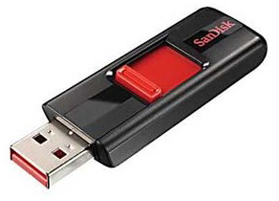

Latency – an audible delay between what you’re hearing compared to the input. It occurs in the A/D and D/A processes when the CPU is working hard; the most powerful computer can process just so commands at a time, and sometimes can’t keep up.

Bit resolution – an expression of the accuracy with which the A/D converter measures an input signal. A standard record setting is 44.1 kHz with 24-bit resolution …it is an acceptable balance of storage space, ease of use and audio fidelity.

