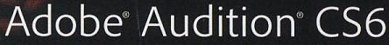  CLASSROOM IN A BOOK® | Chapter 3  Basic Editing

Zooming:
- allows extremely precise edits in the normal workspace
- lets you also see zoomed out status in the overview window at top

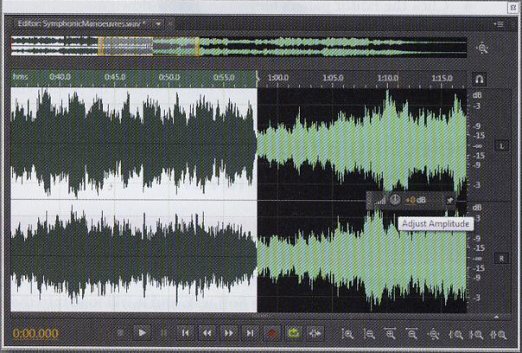
p.45

Selection:
- the process of specifying which parts of a file you want to edit
- click and hold your mouse as you drag it to the end of the area of editing
- the selected space turns white

Clipboards:
- just like cutting & pasting in a word processing program, Adobe Audition allows you to cut and paste
- the software has five clipboards in which to temporarily store audio for later pasting

Music Editing:
- background music often needs to be lengthened or shortened
- looping is used to lengthen a piece of music
- a loop is a piece of audio that repeats as often as the producer needs it to
Artifacts:
- any unwanted remnant of sound that remains after an edit
- most common is the pop, or popping sound resulting from hard consonant sounds (b, c, d, g, p, t)
- pops usually result from being too close to a microphone
- artifacts can usually be visually spotted and removed

