  CLASSROOM IN A BOOK® | Chapter 14  Automation

Automation – records the control changes you make while mixing, including track parameters and effects

Audition doesn’t offer automation in the Waveform Editor but it offers two types in the Multitrack Editor:
- clip automation – every clip includes two default envelopes…one controls volume, the other controls stereo pan
- track automation – similar to clip automation but more flexible…works in either the Multitrack Editor or Mixer view...individual tracks can be automated:
- volume
- stereo pan
- mute
- equalization
- rack input level
- rack output level
- rack mix
- rack power

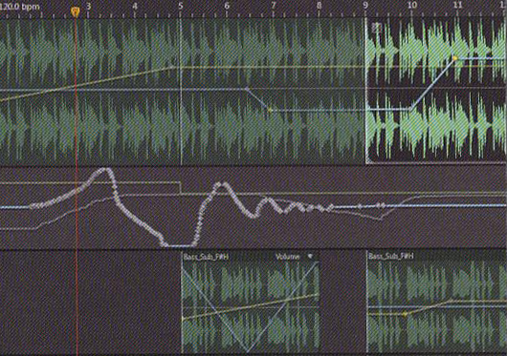

The control changes are recorded as envelopes – or lines superimposed on a clip or track – that graphically indicate the value of the parameter being automated over time. There are multiple ways to create and edit envelopes.

You can add control points called keyframes along the envelope to change the line’s shape. A keyframe is a point on an automation envelope that represents a particular parameter value.

◊ Standard keyframes have a diamond shape
□ Hold keyframes have a square shape

So which is better…clip or track automation?
The most important consideration is that you can create complex volume, pan, or effect changes within a clip, but then subject that to overall level changes using track automation.

