QUICK HISTORY OF RECORDING

1877 – Thomas Edison used tinfoil wrapped around a metal cylinder to playback human voice; his machine was the phonograph.

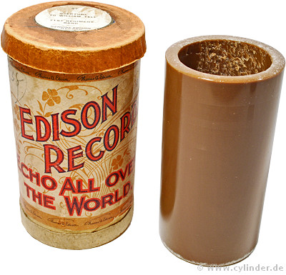  Edison wax cylinder & container | 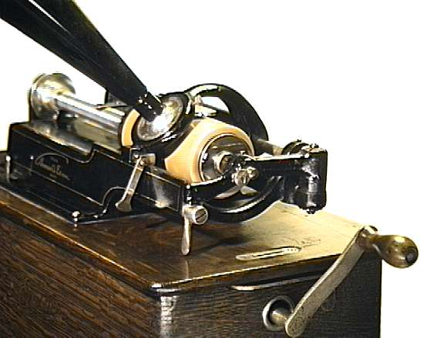  Hand-cranked Edison cylinder player

Cylinders of pre-recorded music were problematic:  - difficult to mass produce  - limited playback durability.  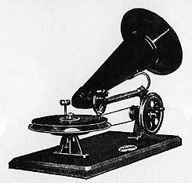  Berliner’s Gramophone | 1887 – Emile Berliner developed the gramophone, a machine to play flat, recorded metal disks or records  1878 - Oberlin Smith proposed recording telephone signals onto a length of steel piano wire.  1940s – vinyl recordings became state-of-the-art; less noisy  1948 – CBS Records introduced 33 1/3 rpm long-playing records

1949 – RCA introduced 45 rpm discs; not compatible with CBS system
1953 – CBS & RCA made record players to accommodate both speeds  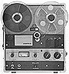  Ampex tape recorder | post-WWII – age of audio tape:  - reel-to-reel (open reel) (1946)  - broadcast cartridge  - cassette  - 8-track (mid 1960s)  - DAT (1986) | 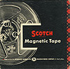  reel of Scotch recording tape
S

THE DIGITAL AGE
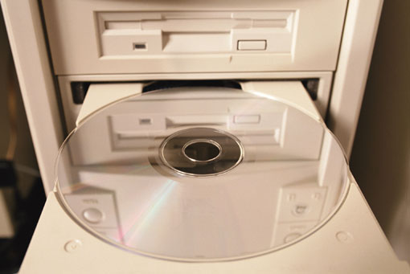  Digital Age - recording converges with computers | 1983 – digitally recorded compact discs (CDs) debuted  1991 – Alesis developed ADAT helical scan format using S-VHS videocassettes  1992 – Sony introduced mini-disc technology  1992 – MP3 file format allowed digital recordings to be compressed into smaller files

