Microphones and Sound

The microphone is a transducer – it changes the energy of the motion of sound into electrical energy.

Sound is a vibration – a specific motion – of air molecules. A sound source creates changes in air pressure, causing alternating waves of compression (dense dots) and rarefaction (sparse dots). When molecules are pushed together, they are said to be in compression. Areas of low pressure, where molecules are pulled apart from one another, are called rarefaction.

Nature of Sound: Frequency
- Your Ears – humans can hear very low frequencies from about 35 Hz to ear-piercing sounds near 20,000 Hz.
- How Frequency Shapes Sound – higher-frequency sounds like consonants lend intelligibility to speech. The transducer (microphone) is necessary to reproduce high consonant sounds otherwise human speech becomes less intelligible. Music that lacks high frequencies is muddy and dull. High frequencies add clarity & vibrancy.

Nature of Sound: Amplitude
- A way to measure sound volume is by measuring it in decibels (dB).
- The higher the decibel reading, the louder the sound.
- An increase/decrease of 1-2 dB is the smallest change in sound level a human ear can perceive.

Other Characteristics of Sound:
- Pitch – the ear and mind’s subjective interpretation of frequency and loudness, signifying the way we hear a frequency. The human ear doesn’t hear the same way a scientific instrument does.
- Velocity/Distance – sound isn’t too fast; it travels 1100 feet/second through air, or 750 miles/hour. It travels four times faster through water. As sound travels it loses its intensity.
- Decay – the amount of time it takes for a sound to die out in a room with reflective walls.

Microphone pickup patterns:
Omnidirectional – picks up sound equally from all sides | 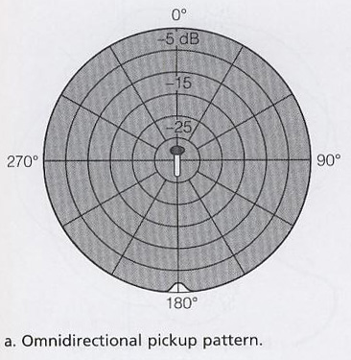
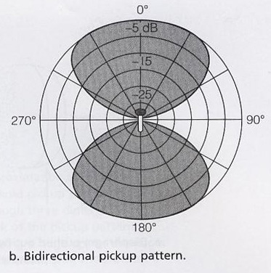 | Bidirectional – accepts sound from the front and rear but rejects sound from the sides
Cardioid (or Unidirectional) – picks up sound from only one, heart-shaped direction | 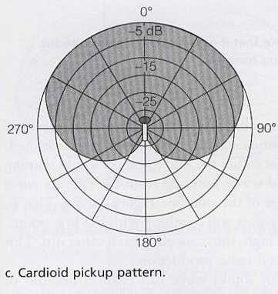
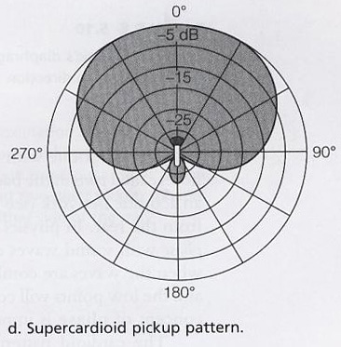 | Supercardioid – has a tighter curve in front and a lobe in back
Hypercardioid – has an even narrower front angle and bigger rear lobe | 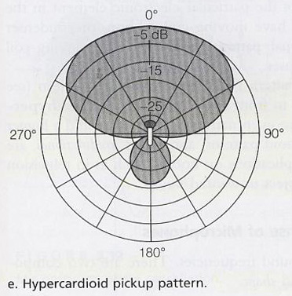

Types of microphones:
- Hand held – used mostly for field interviews; able to reject or minimize handling noise
- Studio, Mounted – larger than hand held mics and more sensitive to handling noise so they are mounted on booms or stands
- Headset – provides hands-free operation during sports play-by-play; they are successful in rejecting background noise
- Lavalier – clips to clothing & is most often used by TV anchors
- Shotgun – for long range pickup mostly in TV & film
- PZ – pressure zone – very low profile for unobtrusive use on table tops

