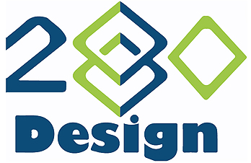
A project of DGME280
Digital Media Management
Mount Washington College
3 Sundial Avenue
Manchester, NH 03103

July 9, 2015

Thank you for considering 280Design to review and help maximize Mount Washington College’s Internet presence. Based on our meetings, we propose the following deliverables:

- Written analysis of online presence
  - existing website(s)
  - social media (Facebook, Twitter, LinkedIn)
  - YouTube channel

- Creation of banner ads

- Videos
  - production of new videos suitable for posting to the College’s YouTube channel
  - written critique of existing videos on the College’s YouTube channel

We believe our efforts will assist Mount Washington College in reaching more of its target demographic resulting in increased student recruitment. We look forward to exceeding your expectations. Please feel free to contact us with any questions or concerns.

Sincerely,

Joseph Cardello Daniel Milton

