 | Chapter 2  Interactive Project Management 101

[p.16] “…the project manager is the epicenter of activity. She is the all-knowing, all-seeing eye. She anticipates the needs of the team members and solves their problems before they can blink. She…fights off the attacking gang of risks and roadblocks.”

What is Interactive Project Management?
A constant mix of hard & soft skills, macro & micro assessing, thinking & acting, being proactive & reactive…the critical skills are:
- thinking
- analyzing
- communicating
- motivating

Interactive Project Management requires attention to:
- numerous expertise areas working on the same thing at the same time
- client with varying degrees of knowledge of (or interest) in technology
- technology that changes daily
- business objectives & goals must be accounted for at every step
- end users who are an amorphous (vague, shapeless) group of stakeholders with a variety of needs

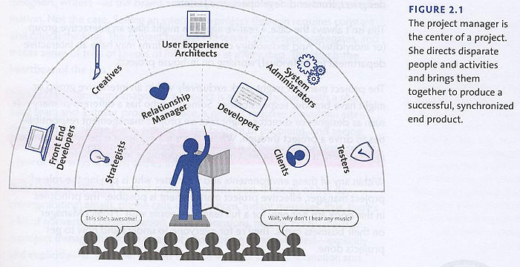

To manage a project properly requires an overall view of the project…the project manager (PM) must always be managing, and therefore, should not take on any other role.

Project Management includes a set of critical tasks:
- planning proactively – forecasting provides a general idea of what’s going to happen and when…the project starts with outlining how it will happen… nothing ever goes according to plan so the project manager must always be asking questions and mentally remaking the plan
- reacting appropriately – the two most common elements to be dealt with are problems (something went wrong!) and new developments (something changed!)…if it’s a problem, what needs to be done to keep moving forward?…if it’s a new development, was it new technology, or new requirements?
- communicating actively – an effective PM spot gaps in communication or expectations…and knows when to connect people to information effectively
- observing vigilantly – the PM must push people…not everyone gets it right at first…all team members must perform up to the expected standard

The PM sets the emotional energy of the team…establishes expectations with the client…follows through on promises.

Qualities of the Perfect PM:
- personable – since the job is about working with people, the PM must be likable & enjoy interacting with people…you must work with people, not around them
- detail oriented – PM’s must see, remember & address details
- naturally communicative – it’s not just what you say but how you listen
- actively online – must be curious about technology and participate in it all the time…because technology changes so rapidly none of us can afford to learn only one job!

