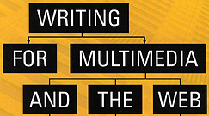 | Chapter 2  Writing for Many Media

IM writers must master several techniques:
- Writing to be read (journalism, copywriting, poetry)
- Writing to be heard (radio, narration, podcasts)
- Writing to be seen (presentations, film, video)
- Writing dialogue

I. TEXT
Blog – a web log
- a website (or portion of a site) that allows easy creation of additional content by multiple individuals
- info is posted on a regular basis with the newest posts at the top
- blogs can be restricted to one person…sets of individuals who register and use a password…or everyone
- commercial sites often use blogs to present news, PR & customer service
- tone is usually very personal & conversational
- often ends with a provocative question to encourage response

General tips for writing blocks of text:
- be accurate, check facts, understand what you are writing
- keep sentences short and use simple sentence construction
- the lead (first) sentence tells simply and clearly what the text is about
- use the active voice (“the robber hit the victim” rather than “the victim was hit by the robber”)
- use descriptive nouns and verbs; avoid adjectives and adverbs
- avoid jargon or technical terms unless you are writing for a specialized audience
- write for one person not a large, faceless audience

Usability – how easy it is for users to perform tasks or to get info from a multimedia program or website
- most people read more quickly & comfortably from a printed page than from a computer screen
- many people don’t read websites…they scan them for they info they require
- once they have located pertinent material users may be willing to read longer, detailed text
- understand the users expectations of a site; this requires research
- remember that about 8% of men (and a smaller number of women, have trouble distinguishing colors

Writing Effectively for Scanners:
- use highlighted keywords, varied typefaces or color
- meaningful subheadings
- bulleted lists
- one idea per paragraph
- half the word count (or less) than conventional writing
- Inverted Pyramid
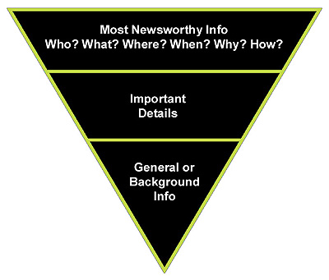

Information Display:
- the home page should clearly & simply describe the site’s purpose
- too much text on the home page may slow down the user’s search for info, or discourage them entirely
- use a consistent style – if links are blue and underline don one page, don’t switch to a rollover system on the next page
- statistics are best presented in a visual form like tables or charts, not in text
- tables are also useful for comparing information
- users prefer short line lengths
- they can actually read faster with longer line lengths
- utilize glosses – bits of explanatory text that appear when the user moves the cursor over a link…glosses help the user understand where the link is going
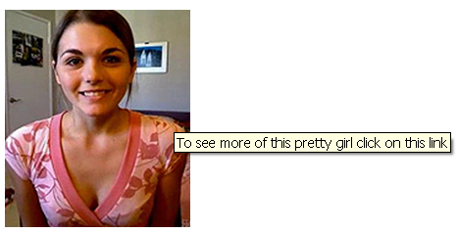

Editing – most IM projects don’t have full time editors like a newspaper would have; editing might be done by:
- clients
- instructional designers, information architects or content strategists
- game or exhibit designers
- subject matter experts
- a copy editor
- the writer

Style Guides:
- most projects provide editorial guidance through a writing style guide
- if none exists, create one (think in terms of the brand standards document in a digital media project)
- popular options are The Chicago Manual of Style or The AP Stylebook and Briefing on Media Law

Editing Commands:
- track changes – Microsoft Word and other word processing software offers this option under the Tools menu
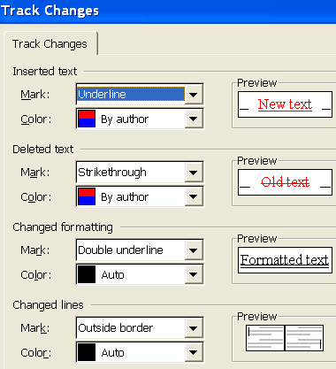
- handwritten notes – be familiar with standard editing symbols like “delete,” “insert,” “replace”
- comments in a second document – clients may write their feedback in a separate document

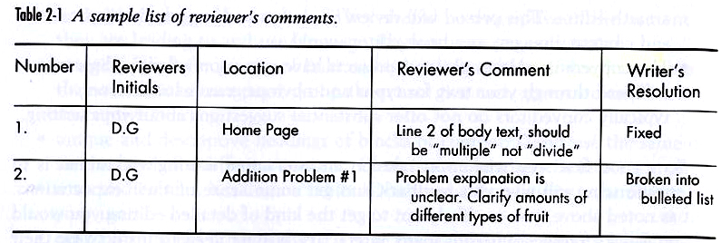

II. AUDIO

Writers use audio to deliver the bulk of the content’s meaning for three reasons:
- audio is cheaper to produce than video
- audio files are much smaller in size than video files
- podcasts are very popular

Like a radio writer, IM writers who employ audio must:
- write conversationally, the way people talk
- write material to be understood on the first listen
- keep it simple – avoid abbreviations…trade jargon…lots of numbers…unfamiliar names…parenthetical expressions
- read your copy aloud – better yet, have someone else read it aloud to you
- write visually – a well-written piece should stimulate vivid images in the listener’s mind

III. VIDEO

A user reads print and hears audio. However they see the results of writing in a video. Typical concerns include:
- Showing, not telling – use action to present the information…rather than long-winded interviews about the subject, show the subject
- Structure – a clear grasp of the story’s structure is required; shots build scenes…scenes develop sequences…sequences create plots & subplots
- Interactivity & Chunking – video is just one part of an interactive project…most of the time the project needs to be broken into smaller chunks, or units
- Exposition – establishing the key elements of a narrative including character, time and place, and backstory…without proper exposition the characters become shallow, themes are undefined and the setting is unclear
- Setup – the hardest element to portray in video…it’s especially important in an informational video where the user needs context to understand the content…in print it is easy to tell the user some background information but in video it must be shown
- Characterization – finding & developing unique characters is essential
- Conflict – most video focuses on conflict
- Cost – since video production is costly, writers must always be aware of the complexity of the story

