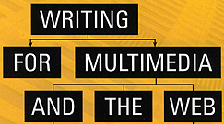 | Chapter 3  High-Level Design, Management, and Technical Skills Useful to the Interactive Writer

Information Architecture (IA) – the overall structure & navigation of an informational multimedia piece. Key issues in IA include:
- clearly identifying communication & business goals

- understanding key needs of the targeted user, including the specific tasks they need to accomplish…these needs are incorporated into a narrative called a Use Case or a User Scenario that tracks the user’s path through the site or program

- organizing information into categories & subcategories

- deciding how the different categories & pieces of info will be linked so the user can easily navigate & interact

- establishing types of interaction & functionality that will be allowed…and what technology is required (databases, simulations, etc.)

Good information architects know how to hook the user by placing the most appropriate content on the top level of the interactive program.

Interactive architects perform most of the same duties as information architects, but are expected to contribute more to the overall user experience including suggestions on interface, design, usability, and online applications.

Common deliverables for either type of IA:
- use cases or user scenarios – defining how a user will use the site or program
- content outlines – a hierarchical grouping & prioritizing of content
- process flows or sitemaps – chart the information flow of an information product, or the process flow of an activity
- wireframes – screen or page level illustrations showing the arrangement of information…sometimes static illustrations, sometimes showing simple interactivity

High-Level Narrative Design – defines the major elements & organization of a project
Content Strategy – involves decisions about the most effective way to present content for the user while achieving the client’s business goals

Writing for Search Engines:
Link popularity & click through traffic are just as important as text, so a web writer needs to write in such a way as to improve a site’s ranking on search engines. Tools include:
- site titles
- site text
- meta tags

Flowchart – a tool for visualizing & organizing the branching structures of a multimedia program or website…purposes of a flowchart include:
- to design interactions – lines with arrows between labeled boxes on a chart make it easier to understand what links with what
- to see the effects of revisions – interactive media changes on one screen will affect all of the material it is linked to
- to chart character development – writers must insure character change is properly set up and consistent in each plot line
- to present material to clients
- to communicate with the creative team
- to track large productions
- to form the basis for the user’s sitemap

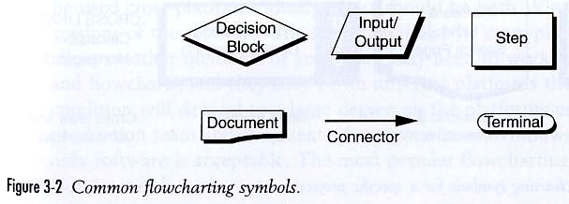

Flowchart Symbols make charts more useful; the goal is to provide a clear visualization of the project structure. Common symbols include:
- Decision Block – a point where the user must make a choice that will determine the next step in the process or information flow
- Input/Output – user enters data of some kind
- Step – a single step in a process
- Document or Page – a single screen or web page, usually contains multiple symbols
- Connector – links between symbols indicating process or information flow direction
- Terminal – beginning & ending points of a process

Flowcharting Software:
- can export a chart in standard formats like GIF, JPEG or HTML
- can be used cross-platform; ideally there are versions for Mac and Windows

Storyboard – preliminary text & graphics presentation of a multimedia or film program…images of the main screens are combined with text explanations of the elements and how they work together

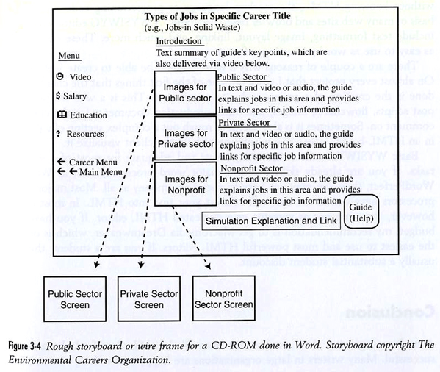

Database – a useful tool when writing, organizing & managing large, complex projects…it makes information more readily available to the user. Many people are scared by unfamiliarity with databases. Writers don’t need to understand how they work in order to incorporate them in a project!

WYSIWYG HTML Editors:
Stands for “what you see is what you get”…a software program like Dreamweaver® that easily creates web pages without the writer needing to learn Hyper Text Markup Language. The software is capable of text formatting, image layout and linking.

