 | Chapter 7  Defining and Achieving Goals for  Informational Multimedia and Web Sites.

The focus of Part II of this textbook is on informational multimedia programs that do not use fictional storytelling techniques.

DEFINING INFORMATIONAL MULTIMEDIA & WEBSITES
Most IM and websites are designed to communicate information or to allow users to perform information-based tasks.

If the info is about something concrete (a person or place), informational multimedia follows the documentary tradition by presenting the info through actual locations and individuals.

If the info is more abstract (a process) the material can be presented through text, visualizations (charts) or interactive devices like calculators.

Many informational programs are created using narrative fiction (character-driven training programs which use actors, or dramatic recreations of historical events).

DEFINING THE GOAL: BUSINESS CONTEXT, DATA & USERS
Before you can start building an IM program you need to clearly define your user and the goal for the project. There are three component of defining the project goal.

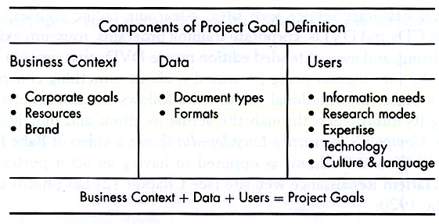

Business Context
- What does the client think they need to get out of the project?
- What resources can the client commit (budget, staff, subject matter experts, staff to maintain the project after launch)
- What is the company’s brand? How is the company perceived or how does it wish to be perceived?

Data
- What type of info does the client already have? What areas of info are lacking?
- In what format does the data now exist (databases, printed brochures, videos, or in the heads of key personnel)?

Users
- What information or activities do users want from the project? Will they need to perform online transactions?
- How does the target user typically look for information? Do they like to search or browse?
- What does the typical user already know about the product or topic? Does there need to be a lot of background info or can we get right to the main content?
- How will users access the info (PDA, smartphone, laptop, computer, kiosk, etc.)?
- What is the dominant culture and language of intended users?

Goals should be clearly defined, measurable, and limited in number.

Business Context + Data + Users = Project Goals

TECHNIQUES TO ACHIEVE COMMON INFORMATIONAL GOALS
Informing and teaching are the most fundamental…and are also the concern for most writers.

- To persuade – The Greek philosopher Aristotle (384-322 BC) suggested three modes of persuasion to change someone’s heart and mind:
- Ethical – if your viewer believes the speaker, they will believe the speech
- Logical – convince us with facts
- Emotional – connect to our emotions…this is the approach most used by advertisers (see also Persuasion Theory document)

- To entertain – all programs must engage or entertain to some degree…whether a program is informational or pure entertainment, or somewhere in between, is an important consideration for the writer

- To enable transactions – most websites allow users to perform an activity (like buying merchandise or opening an account)..the writer must teach the user how to perform this transaction…if it takes too long or is too complicated the user will leave

- To create a sense of community – online user forums attempt to foster a sense of belonging through common interests (ideas, photos, music)…these techniques can make a user feel like they belong to a like-minded community…much of the information the writer produces will reinforce values and common assumptions

- To inform – the writer wants to provide users with access to a large body of info…the user isn’t expected to access all of it, but just that which they want or need…databases are a common tool
- group info by categories – criteria like place, time, theme…also useful to create complex query capability to search across several criteria at once
- concept maps – a way to visualize categories in a database according to a visual image or map
- customized & personalized info – requires presorting the database and only presenting the user with the info they need or want; in order to do this the user’s preferences need to be collected in one of two ways:
◦ customization – the user consciously inputs their preferences by
filling out a form or clicking through a questionnaire…learning
programs can be customized by allowing the user to choose which
sections they want to study and in what order
◦ personalization – the computer learns the user’s preferences by
previous activity on the web site…learning programs can track the
user’s progress and adapt the type and difficulty of subsequent
sections based on user performance
- search – one of the most useful tools when accessing a large body of loosely related or unrelated info…most websites of any size have an internal search tool capability
- guides and agents – characters who lead the user through material…repeated interactions could allow agents to continually refine their knowledge of the user’s preferences

- To teach – in a teaching program the info may be more narrowly defined…the writer has a clearer goal of what info they want the user to take away from the experience

CHARACTERISTICS OF INTERPERSONAL INSTRUCTION
- Immediacy of response – it is psychologically important for the learner to feel connected, so an action taken by the user should generate an immediate response (screen change, text message or a sound)
- Feedback – there is no consensus on what kind of feedback to provide or when, but it is important for the user’s experience
- Bidirectional Communication – let the learner communicate through a variety of methods (typing text, manipulating images, sound)…people have different learning styles (watching, doing, analyzing) so the message should be presented in a variety of ways
- Interruptibility – students should have the ability to stop or pause the program at any point and go in a direction more useful to them…users should be able to bookmark the spot at which they left a program so they don’t have to start all over again the next time they login
- Help – it is important to build a help function into the interface design right from the beginning….writing help pages can be extremely time-consuming
- Nonsequential access to information, adaptability and options – a learner who has difficulty in a certain area can be tracked and directed to specific sections geared to that particular problem…one simple technique is to allow students to choose a level of difficulty and advance at their own pace

MULTIMEDIA GAMES AS TEACHING TOOLS
Many computer games exhibit sound instructional design principles. For example:
- Many games have levels of difficulty
- Games offer multiple ways to solve the same problem
- The nature of the game experience makes users happy to exercise a skill they have mastered
- The excitement generated by games can make students feel addicted to the experience
- Students who haven’t done well with traditional forms of instruction often do well with games

