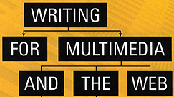 | Chapter 8  Informational Multimedia and  Web Architecture

COMMON INTERACTIVE ARCHITECTURE STRUCTURES:

- Linear Structure
- has no linking or interactivity
- used for the presentation of key information that shouldn’t be interrupted
- the structure of most motion pictures & TV shows
- think of a desert highway with no crossroads
- can be used in two ways:
- problem-solution structure – set up a problem linearly and ask the user to solve it interactively
- dialectical structure – set up a dialogue between two differing viewpoints and repeat until a conclusion emerges or the user can draw their own conclusion (think of TV news magazines like 60 Minutes)

- Linear Structure with Scene or Section Branching
- has a few limited choices as to how certain scenes will play out
- a desert highway with a few detours that always return the traveler to the same road
- used in training pieces that explain step-by-step concepts
- often an option of detouring to a review of the concept, after which the user is returned to the page they left
- may force the user to link to different sections for review

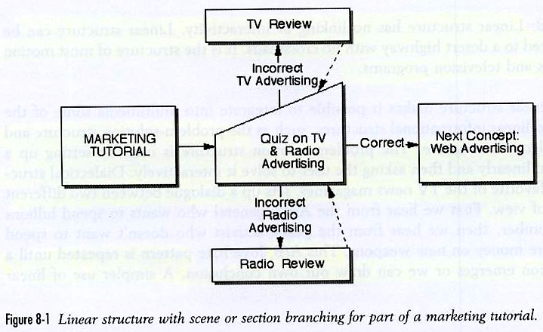
- Hierarchical Branching
- information is organized according to categories and subcategories so users can find the info they need
- the dominant structure on most websites
- there is a hierarchy of ever-narrowing choices
- two possible pitfalls:
- branching explosion – creating too many user options is difficult for the writer because the amount of material to produce is prohibitive…this can be controlled by limiting category choices at each level of depth, or by allowing search & site maps to find other information
- too many levels of info – user can get lost

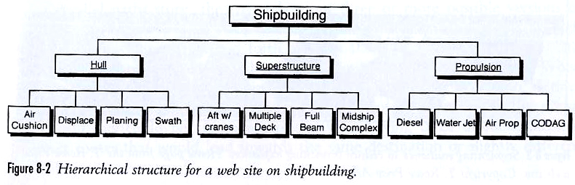

- Single-Level Linking
- no hierarchy in this approach
- user is presented with a problem and given a number of possible resources for solving the problem
- resources can be accessed in any order
- this approach is fairly rare on a complete interactive program because it must be limited to a single topic with limited options

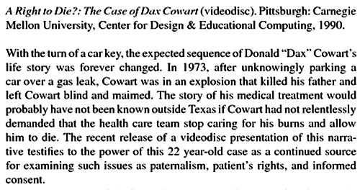

- Parallel Path or Multipath Architecture –
- approach is borrowed from interactive narration where a main story structure is parallel path stories
- writer lays out three or more possible versions of the same basic story
- as players move through the game they move back and forth through the different versions
- used most often in online transactions or activities where user is trying to accomplish a specific goal
- to accommodate a variety of users the writer must prepare multiple info paths
- context sensitive help can be available from a drop down menu
- approach is different than Hierarchical model because users can easily move from one information path to another

- Dynamically-Generated Database Driven Websites
- uses technology to assemble web pages for specific users
- many sites consist of blank framework templates and the actual content is drawn in small chunks from databases
- the page seen by the user is dynamically assembled in their browser because it is personalized by server software
- used most often for transactional sites that are selling stuff (Amazon, etc.)
- if you have visited before you’ll see ads & products drawn from your profile
- if you haven’t visited before more general ads are displayed

PASSIVE VERSUS ACTIVE INFORMATION DELIVERY:

- Passive – when information is organized by categories and subcategories in a clear manner…it’s not very engaging

- Active – demands more from the user than just click-and-read…user needs to get involved…if the goal is to engage the user to fully experience and learn a topic, active delivery should be your choice!

GETTING BEYOND CLICK-AND-READ:

A simulation is an experience or activity recreated virtually on screen. The structure is dictated by the activity.

Use 1, Problem Solver – in educational programs the simulations usually involve a problem for the user to solve or a task to accomplish

Use 2, Gamer – the user takes on the role of a player in a game…not all games are simulations but if the player actively takes on the role of a character, they generally are

Use 3, Explorer, Worlds Structure – user takes on the role of an explorer or traveler who explores a world of information…there is no set problem to solve or sequence of actions to be accomplished. The world structure organizes available options in a graphic spatial representation or descriptions of events that will occur in each location…flowcharts not very helpful here.

The best way to write a simulation is to start with the most basic categories (characters, locations, etc.) then break those down into subcategories.

The next step is to fill in the details of each object with:
- attributes
- rules of behavior

OTHER APPROACHES:

- Reporter – some educational programs allow users to report on their multimedia experience by using a virtual camera and word processor to write a journal…although you are playing a role, your actions don’t affect what happens
- Tools – a way to engage users is to give them tools in the program to discover the information (interactive checklists, calculators, etc.)
- Virtual Advisors – online forms that ask the user a series of questions…after the form is filled out the online advisor suggests the proper product to buy or action to take

[p.121] “An additional benefit of an active information delivery, particularly a simulation, is that in addition to teaching a specific skill or subject matter, this type of multimedia is also very successful at teaching students how to learn.”

