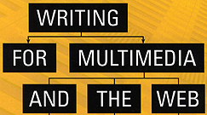 | Chapter 11 Case Study  Corporate Web Site:  T. Rowe Price

Five Basic Categories of Websites
Personal  created by individuals to share information about themselves and their interests | Educational  created by schools, museums & educational institutions; also  e-learning courses | Governmental  created by government agencies & elected officials  as a service to constituents | Entertainment  created by publishers, movie studios, TV companies, computer game companies & others for online entertainment | Commercial  created by businesses to promote and/or sell products & services
↓
Types of Commercial Websites: ←←←
Transactional  performs transactions such as ordering merchandise…  all the content revolves around that function | Consumer  a fun & highly visible promotional site without much information | Marketing  Communications  lots of information about a company including it’s products & contact info | Content  extensive information on the general products & services of a company…  the goal is to draw users in with strong content…  financially supported by partial transactional use or online advertising

T. Rowe Price is an investment management firm with headquarters in Baltimore and offices globally.

Much of the information on its site is dynamic in that it is updated frequently or is customized for each user.

“…it is important not to change a site that deals with the general public too quickly and too often. Users don’t want to have to completely relearn how a site works every six month.”
--Emmett Higdon, Assistant Vice President of Internet Services, T. Rowe Price

Challenges – writing and organizing a vast amount of content intelligently from the user’s perspective so that it would be easy to navigate
- because content is organized by product instead of by user, it is up to the user to determine which content is right for him/her
- user-centered design was employed
- content clearly grouped according to user needs

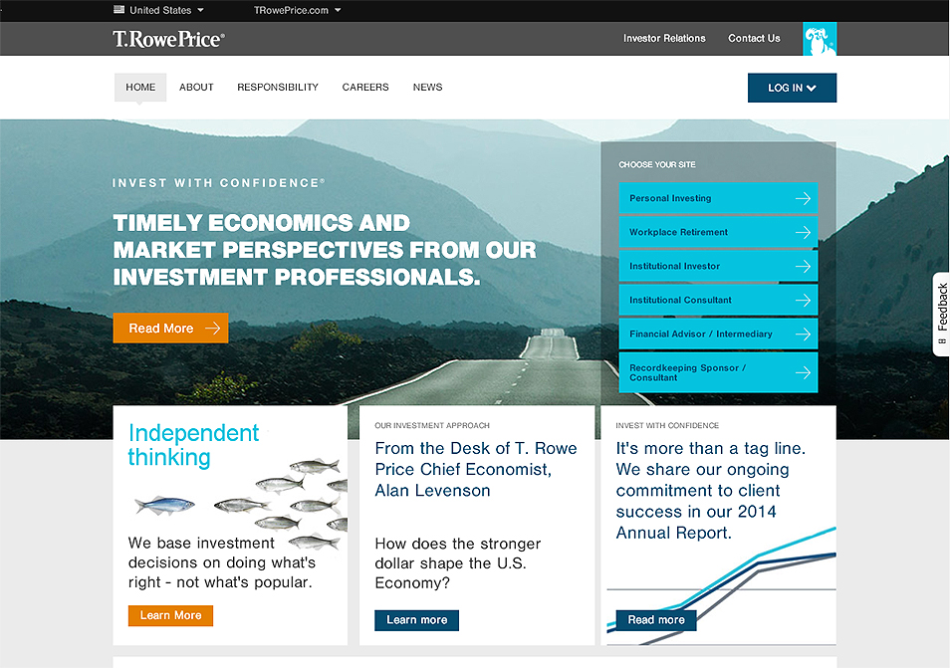
2015 version

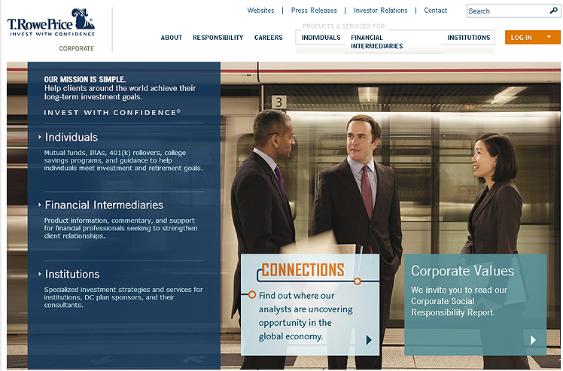
2013 version
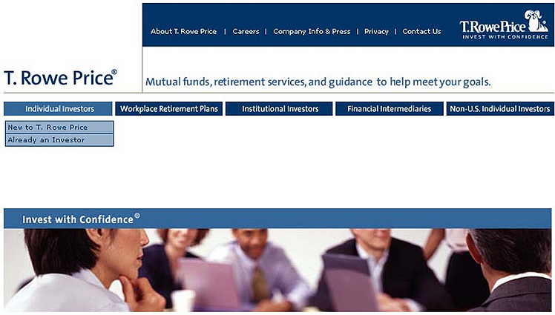
2006 version

Customization – employed in earliest versions and each subsequent redesign
- makes the site easy to navigate & understand
- each user (rather than a software program) specifically chooses what content they want displayed
- such customization allows user to control what will be displayed on future visits

Custom Portfolio View – a complex example of customization
- Create View tools allow user to create custom portfolio page
- each time user logs in he/she sees only the investments in his/her account

Personal Guides – interactive tutorials that explain investment topics
- help user define their information needs
- ask users a series of questions in an interactive tool
- users are presented with analysis with recommendations based on they data they input

Navigation – goal or redesign was to make important information no more than two clicks away
- first generation users disliked hierarchical navigation
- earlier versions required users to click 3-4 times to get what they wanted
- navigation completely redesigned for versions 2, 3 & 4
Drop-Down Menus & Global Navigation –
- global navigation is site-wide to all important subject areas
- local navigation deals with a particular section of the site and was primarily in left column on versions 1, 2 & 3
- when navigation links are clicked drop-down menus provide additional choices

Search Box – an important navigation feature for every page
- important because it is the first place many experienced users go
- a login button also appears on every page so users with accounts can access their info quickly

