 | Chapter 12 Case Study  Research Portal Web Site and the Online  Feature Story: Britannica.com and the  Harlem Renaissance

This was a feature story created for Britannica.com, a web site owned by Encyclopedia Britannica Online [click here for 2015 site].

This site presents a synthesis of recommended links to other websites, article from Britannica’s own massive database, and new material such as a news digest and multimedia features called spotlights.

The purpose of spotlights is to engage the user by presenting info in a highly visual and interactive way.

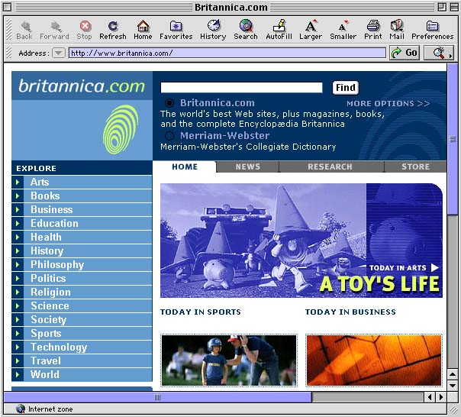
The Harlem Renaissance spotlight feature story was designed to encourage interest in black history. It focused on a key moment in black history – a period of cultural and political activity in the 1920s.

The spotlight utilizes:
- powerful writing
- period graphics
- multimedia elements

The Harlem Renaissance spotlight is no longer available online.

Portals – a website that is a user’s entrance or door to the WWW…designers build portals so users will use them as home pages.

Many portals (like AOL.com or My Yahoo!) allow the user to customize the page so it presents specific info they are interested in.

Because they attract heavy traffic, portals are heavily sought after for advertising and e-commerce.

Unlike My Yahoo!, Encyclopedia Britannica Online (EBO) creates and presents much of its own content.

EBO was originally a free site and the full text of the encyclopedia was available online. The company hoped to offset the web expense with online advertising and sales of ancillary products.

After a time the site was renamed and repackaged and the full text of the encyclopedia was no longer available. Instead, users get a brief summary of articles and must be paying members to see the full text.

The Goal
EOB wanted to present a large body of info by focusing on a specific story, similar to a newspaper or magazine feature story. It:

- Researched the topic

- Created a master list of articles

- Divided the articles into categories...then organized the categories & links into a sitemap with a flowchart

- Identified & located available images

- Finalized the navigation & interface including a hot spots map of Harlem

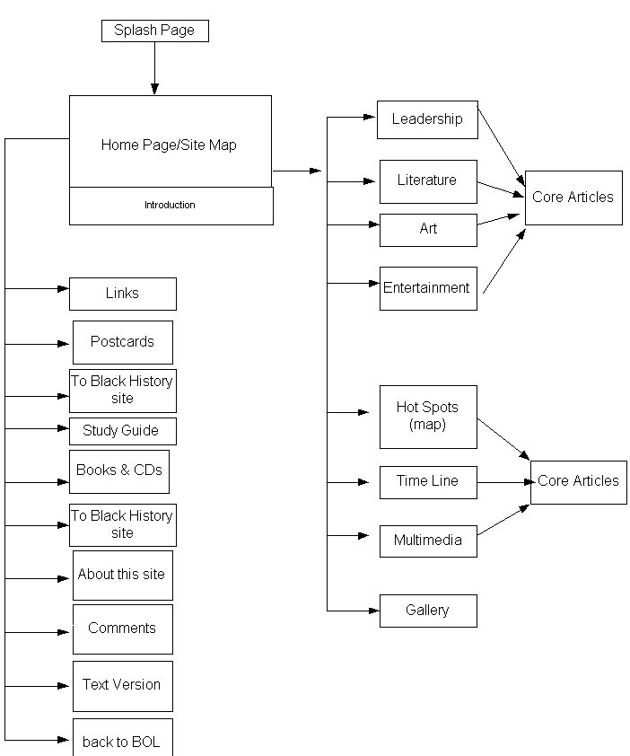

Graphics
Text & graphics for each page were rendered as full-page images. The page or image was sepia-toned to add to the mood of the period. Each of the four main sections was tinted with a different color.

This graphics approach limited editing because even minor text changes required re-doing the entire image.

Users with slow telephone dial-up connections also had to wait for the large images to load.

Video & Audio
Extensive use was made of graphics, video & audio as well as an extensive photo gallery of Harlem Renaissance figures & locations.

Hot Spots Map
This allowed users to get an overview of the geographical area of New York but also served as a clickable menu. When the name of a location on the map was clicked a picture & description appeared.

Writing Style
A visual style was employed to engage the user. They were encouraged to click on small “ads” on upper level pages that hinted at deeper content.

“Write as if you are talking to an individual, not a collective group of anonymous Web surfers.”
– site writer Andrew Nelson

Navigational Approaches
- Hierarchical Menus
- Main Categories – from upper level pages the user could get to the main menu with just one click. Four categories were used: Leadership, Literature, Art & Entertainment
- Bibliographies – each page contained a TO ARTICLES link

- By Location – users could access info through the Hot Spots Map

- By Time – timeline allows users to click on a specific year and retrieve a list of key events…key people & events are clickable for detailed articles

- In Context – all articles provided text links via highlighted words

- Send a Postcard – a link at the bottom of each page allowed users to send e-mail picture postcards to their friends

- Study Guide – a link at the bottom of each page provided additional activities

