 | Chapter 13 Case Study  E-Learning: Interactive Math  and Statistics Lessons

More than $20 billion is spent annually on course materials for U.S. schools and colleges. Billions more are spent for government and corporate training. This material can take numerous forms:
- digital textbooks
- online courses
- supplementary material that supports print textbooks

Houghton Mifflin (HM) is a top educational publisher, established in 1832; its headquarters are in Boston.

HM’s Interactive Math and Statistics Lessons (IMSL) was an example of supplementary material that explains key concepts.
- developed to teach math & statistics to a college audience
- lessons took the form of a key math or statistics concept
- lessons employed audio, animation, video, text & graphics to present the concept
- designed for students who haven’t had good success in math
- most lessons could be completed in under 10 minutes

Each IMSL lesson followed a traditional instructional design: introduction, pretests, concept explanation, example, apply/explore concept, post test to verify mastery.

Each lesson was presented in 8 modules:
- Prepare for the Tutorial – brief summary of lesson in a bulleted list… photo describing a real life application of the concept…summary of basic pre-skills needed…links to pretests

- Study the Concept – detailed explanation of the concept including animation, static images, text & audio narration…student had the option of listening to narration, reading text, or both…student could move lesson back or forward

- Try an Example – screen used animation, static images, text & audio narration to present an example of the concept

- View a Video Example – screen included a short video of a classroom lecture explaining the concept
- Practice Exercises – provided a chance for students to work with concepts they just learned in the previous screen

- Apply the Concepts to Real Life – gave students a chance to solve a real life problem using the concept

- Explore the Concept – a highly interactive exploration custom made for the concept; this is the hardest module for the writer to create!

- Mastery tests – to demonstrate the student had learned the material

The IMSL approach was to create generic material that can support numerous textbooks, or to create a software/shell engine to customize each book with unique content (a software/shell engine is software with certain capabilities such as presenting types of exercises, audio, video, etc.).

Goals of IMSL
“My goals with each lessons were to summarize and simplify materials in a given text of series of text without compromising the integrity of the material. The multimedia presentation had to be accurate and brief…”
- writer Shawn Hackshaw

Production Challenges
- mastering the required software & technical skills
- devising a script format that satisfied the needs of the client, content reviewers, production team, narrator & user

Content Challenges
- understanding specific restrictions, format & style of the interactive lessons
- ensuring that concepts supported multiple textbooks
- reducing vast amounts of content to smaller amounts that could be effectively presented in an interactive, online format
- keeping in mind short attention span of users
- finding ways to explain, visualize & make interactive the complex math & statistics concepts

Software & Technical Skills
Writers for technical subject like math and science required more software skills than other writers.

Creating very clear preliminary models saved the production team time and money.
For IMSL Shawn Hackshaw wrote math symbols & presented illustrations. One of the software applications he used was MathType by Design Science, a professional equation editor that makes it easier to write complex math fomulas. MathType integrates with most word processing software, including Microsoft Office.

He also used MathXL, an XML-based language used to present math in interactive media.

Script Formats – must present content for a variety of audiences with different needs:
● Client – needs a clear, uncluttered visual representation of how screen will
look
● Production Team –needs very specific technical details so they can execute
the author’s vision
● Narrator – copy that can easily be read aloud

Storyboard  - attempted to represent how the screen layout will look by showing placement of illustrations & screen text  - title bar clearly indicated the concept title & unique concept tags  - each element needed a unique tag  - all text was presented along with final frame of the animation  - grayed-in boxes are process, or definition, boxes  - process boxes listed the steps of a procedure  - definition boxes defined a term | 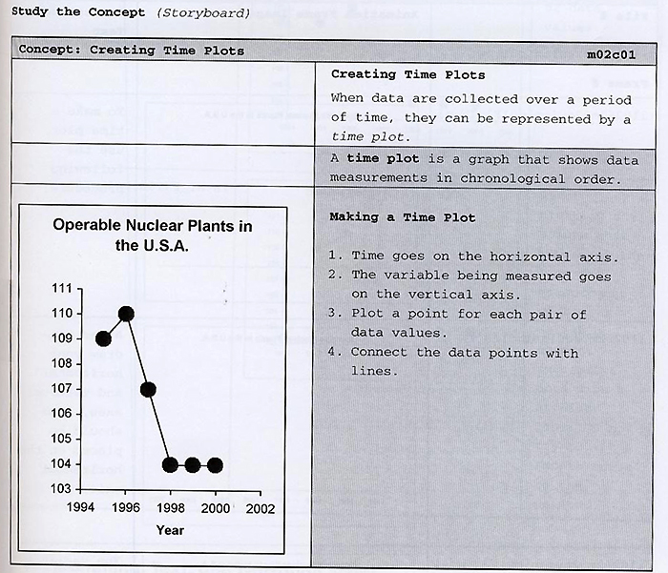

Script Animation Page
- a separate page following the storyboard that addresses content review & production development
- contained the file name of the animation frame on the left…an image in the middle frame…corresponding text in the right frame

Programming, Text & Narration Script [below]
- the final script for each module
- column for images, text & programming
- column for text transcript (student reads)
- column for narration text (student listens to)
- column for project notes

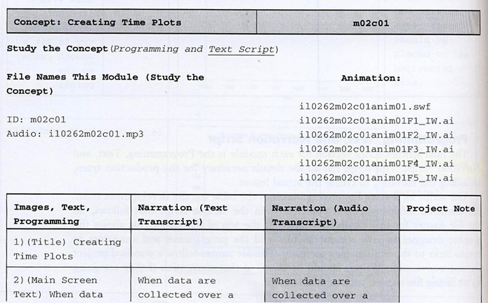
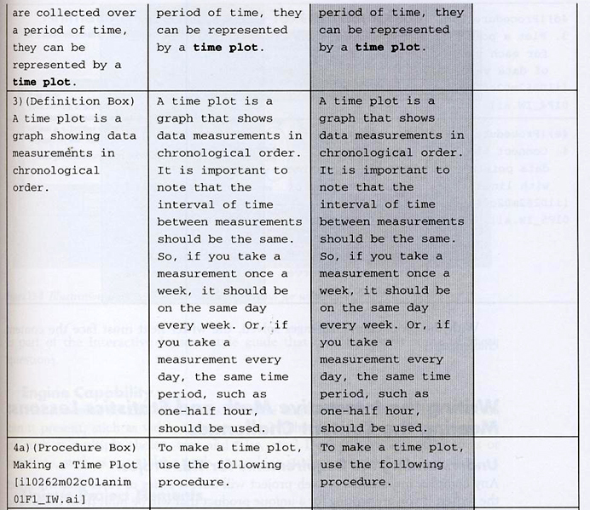
Screen Layout [below]
- what kinds of media or text can go in the interface
- can the screen scroll?
- is the amount of text limited in certain areas?

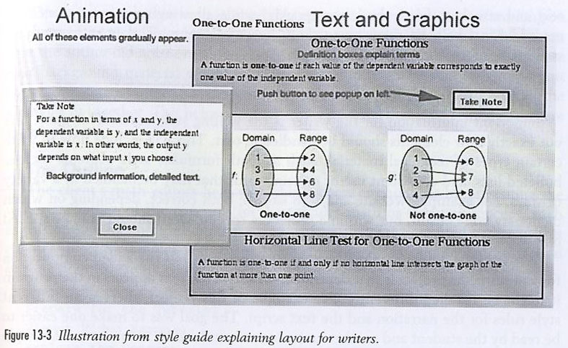

Software Engine Capability
- what kind of media can it present (i.e., video or animation)?
- what kind of exercises is it capable of (multiple choice, true/false)?
- does it have other tools or functions (note-taking or tracking student progress)?

Dividing Content into Various Display Areas
- reading lots of text on screen is uncomfortable for most users
- text should cover just key points
- concepts should be visualized as much as possible in diagrams or animations
- if details are required, include them in the narration

Outline
- client math editors help with the process of chunking info
- a big challenge for the writer is clearly explaining concepts and engaging users

Step-by-Step Instruction & Reinforcement
- when you teach a concept explain what it is
- visually represent it in numerals or a formula
- present it in audio
- develop a picture or animation that illustrates it

Multiple Ways to Interact with a Concept
- give user the option of entering random data to see how a formula changes
- let students experiment with sliding bars to visually see how a range of numbers changes a calculation
- pushing arrows on a graph changes the corresponding formula

