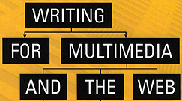 | Chapter 15 Case Study  Training: Vital Signs

Interactive media training programs are increasingly popular because they are faster, cheaper and more effective than traditional types of training.

ELECTRONIC LEARNING TERMS
- Computer Based Training (CBT) – training delivered via a single computer or several non-networked computers

- E-Learning – any training or education delivered electronically or digitally including web courses, video, CBT, interactive TV, Internet, intranets, PDAs, cell phones, etc.

- Online Learning – training or education delivered through computer networks, primarily the Web, but can also include intranets or computer networks

TYPES OF E-LEARNING & CBT PROGRAMS
- Live vs. Self Paced

Live – scheduled sessions presented by an instructor in real-time …students must take the training at the same time and move at the same pace…contact with teacher in-person, via chat, e-mail or phone
- Self-Paced – can be viewed at the students convenience and speed…no live instructor

- Standardization or Customization/Personalization

Standardization – each student views exactly the same content
- Personalization – smart programs that focus on individual user needs by adjusting to the user’s patterns or requiring user info at the start of the program
- Customization – the student, rather than the program, designs how the content will be presented by making certain choices at different points in the program

- Traditional E-Learning vs. Rapid E-Learning
- Traditional E-Learning – deals with complex material and takes weeks to produce…full production team required
- Rapid E-Learning – used for time-sensitive, simple, short shelf-life projects…tools like Microsoft PowerPoint often utilized

Vital Signs was a self-paced, standardized, comprehensive, traditional, computer based training program.

Its goal was to teach specific skills to a clearly defined audience. Entertainment value was minimal. It was a disk-based program offered on individual computers.

Vital Signs was designed to teach trainee medical assistants at Harvard Community Health Plan in Boston (now Harvard Pilgrim Health Care).

Reasons interactive multimedia was chosen:
- students were widely dispersed; it was difficult to gather them together
- students had varied backgrounds
- students could learn at their own pace
- it was important to keep the information consistent
- this method reduced training time
- it was cheaper…once the program was complete there were no further costs until it needed to be updated

Specifically, the program taught:
- how to take temperature
- pulse
- respiration
- blood pressure
- urine analysis

This graphical navigation structure appeared at the top of each page:

The icons (left to right) were:
- thermometer = temperature
- heart = pulse
- lungs = respiration
- manometer = blood pressure
- dip stick = urine analysis

Vital Signs required a design document, which included a content outline that laid out the standard hierarchical format. It did not require a flowchart, though.

The design document was refined after several meetings with creative team members and the client.

The writer developed several drafts of the treatment. When the final treatment was approved the writer generated several drafts of the script.

Challenges
- Content – info had to be delivered precisely…partial understanding of the topic was insufficient
- Time Limit – client wanted students to be able to complete the program in less than an hour
- Audience Issues
- some students had English as a second language
- for many students, this was their first exposure to the topic
- most students weren’t college graduates
- different types of students (internal medicine, pediatrics, OB/GYN)

Differing Goals
- Instructional Designer
- content driven – the need for precise understanding of the info meant the same material must be presented in multiple ways
- clear navigation – if the user finds the program complicated, it fails…navigation must be clear & easy to use
- humanize – put a human face on each procedure

- Writer
- pace – keep people involved…don’t let them go more than 25-30 seconds before being asked to interact in some way
- humor – can be effective as a reward for successful performance, to get people top relax, or as a memory aid
- emotion – elicit an emotional response from users…make them feel like a critical part of the medical team…but also make them aware of the feelings of the patient
- voice of the program – unlike an informational program where the voice can be neutral, align the voice of this program with the user…the tone of voice should never talk down or lecture the student
- style of presentation – make the program an intimate, one-on-one experience

Overall Design
One of the strongest aspects of Vital Signs was how the same information was introduced numerous times. Each time the information was presented in a more challenging manner. There were 9 modules:

- Registration – student pre-registers with his/her employee number & department

- Pretest – student takes a multiple-choice test that is not numerically graded…a dim bulb or bright bulb is displayed to give student an understanding of their strengths and weaknesses

- Humorous Introduction – student meets a patient named Norman, which puts a human face on the interaction…there is a Feedback section on this page that interactively asks user to guess what will happen next

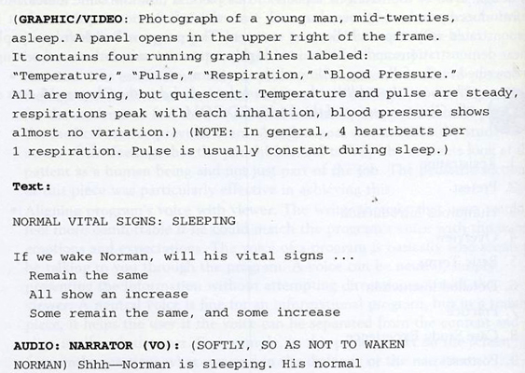

- Overview – piece turns more serious by presenting more factual info

- Basic terms – time for the user to start learning the nuts & bolts of taking vital signs…interactive menu lets them choose what to study first [next page]

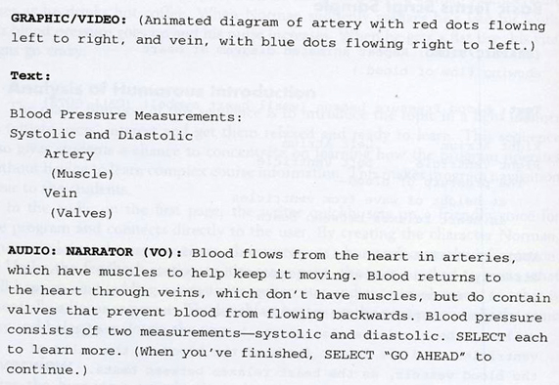

- Detailed Instruction – program moves to the next level of complexity focusing on the user’s specialty (pediatrics, OB/GYN)

- Practice – a highly interactive sequence in which user practices the new skill on a virtual person through an ingenious, interactive animation
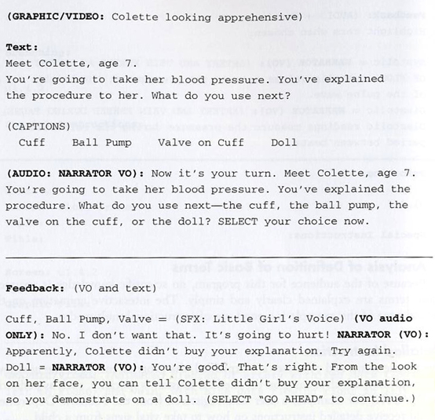

- Case Study Experience – case studies present the same information in different ways…student watches videos of real medical assistant taking vital signs…the challenge is to catch the medical assistant’s errors…students have the ability to stop the disk & replay it

- Posttest – a multiple-choice test with the same questions from the pretest but in a different order…it is not graded numerically but the dim or bright bulb is used…supervisors can access a numerical grade for certification purposes

