 | Chapter 23 Case Study –  Worlds Narrative:  Dust: A Tale of the Wired West

PROGRAM DESCRIPTION  Dust: A Tale of the Wired West was a Western adventure game set in 1882 in Diamondback, New Mexico.  It was produced in 1995 and released on CD-ROM. The company that produced it, CyberFlix Inc., closed in 2005 and its principal now runs a firm called DreamFactory.  The target audience was 13+. | 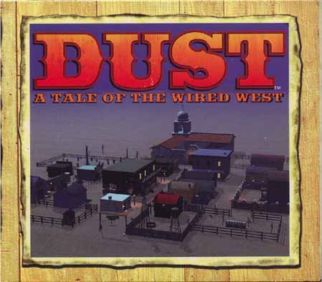

Dust opens with a linear video sequence. The Stranger arrives in town in the dead of night with no gun, little money and a hole in his boots. He enters a saloon and begins playing cards with The Kid (a cheater) and nails his hand to the table, fleeing the saloon. The object of the game is to get cash, a gun, boots, and defend himself against The Kid who is out for revenge.

From the next scene onward, the user becomes The Stranger, seeing what he sees, hearing what other characters say to him. The Stranger’s voice, however, is never heard. The user speaks for him by choosing a series of dialogue choices on each screen.

GOALS
- Create an inhabitable, believable world with its own constants & laws
- Give the user the maximum possible freedom to explore this world & interact with its citizens as part of a complex, interactive story

CHALLENGES
- Creating an inhabitable, believable world
- Giving the user the opportunity to explore this world & interact with its citizens
- Developing a story within a highly interactive world through establishing plot points, characterization, and other story functions

Diamondback is a three-dimensional world populated with about 40 characters
- they are essentially cyber-puppets with lives and personalities
- they are neither videos or animations, but are created from photos of real people and developed into computer-generated animations
- they do their activities in real time (gambling, shopping, drinking) whether The Stranger interacts with them or not
- characters develop significantly during the four days of the game
- if The Stranger does interact with them the characters remember how he treats them which alters the chain of events as the narrative progresses
- there are objects the Stranger can pick up and examine
- sounds heard in the background get louder as the player approaches

The Stranger can move through town exploring buildings, talking to citizens who may help or mislead him. Judging the character of the people he meets is an important factor.

There are periodic games to play:  - Blackjack  - Slot Machine  - Shooting Range  - Hex Puzzle  Success at the games helps the player advance the narrative. | 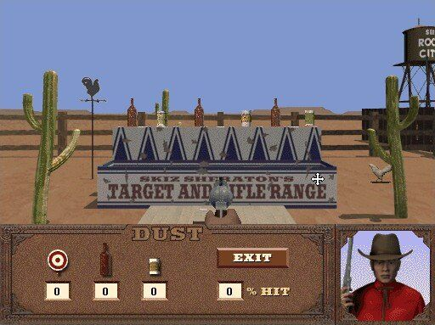

CyberFlix used a proprietary multimedia-authoring tool, DreamFactory, to create Dust.

Writer Andrew Nelson wrote:
- backstory of Diamondback (history of town & characters)
- walkthrough (outline of the basic story line & key interactions)
- game design (a blown-up storyboard showing interactive puzzles)
- table of events (the basis for a hint book with suggestions for how the player moves forward)

From this point on, there was no writing on paper – everything was done in DreamFactory.

There were about 5,000 individual lines of dialogue.

Dust featured an omnipresent narrator who was triggered automatically at key times, especially at the start of each day to tell The Stranger what he had to accomplish.  Short, linear movies appeared periodically to relay important information. | 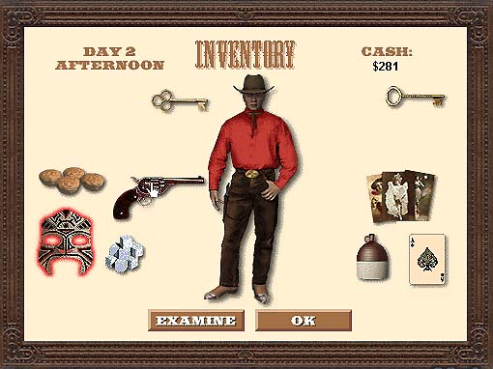

The overall structure is similar to a string of pearls architecture.

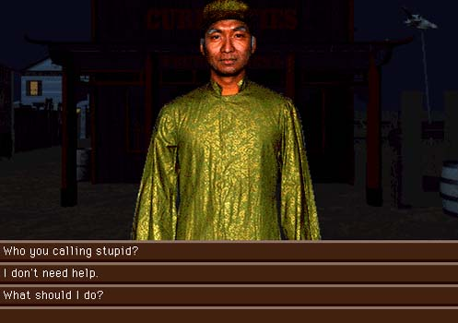 | Getting Help  Diamondback has a curiosities shop owned by a Chinese man named Help. This resource is always available for The Stranger to call on – for help!  Depending on what the player does on one level of the story, he/she is better or less prepared for the next level.

All story paths lead to a common destination, which is a branching of six different endings.

Interactive Dialogue
A major way to get information and have fun in Dust is through talking to the characters.

Conversation continues until the player, as The Stranger, clicks a menu choice like “Thanks” or “Bye.”

How the characters treat The Stranger depends on how he has treated them previously. Marie MacIntosh hates her father, the mayor. If The Stranger is rude to her father, Marie likes The Stranger. [CD_ROM has transcripts of Marie’s character]

Nudging
The writers employed a series of devices to push the player along toward the inevitable shootout between The Stranger and The Kid. Nudges were used to:
- establish key plot points
- introduce characters
- engineer confrontations
- guide the user forward

RESPONSE TO THE PROJECT
- Best Multimedia Game of the Year – MacWorld
- Critical Acclaim – Newsweek, People, Next Generation
- Best Seller for CyberFlix

