DGME310/WRITING FOR MULTIMEDIA – FINAL EXAM – Aug. 18, 2015

Name: _________________________________________

- (3 pts) Text menus, icons, help, on-screen text, narration and linear movies are all examples of what?

2. (6 pts) What are the 6 general goals of most interactive media projects?

3. (3 pts) Fill in the blank. A series of events that are linked in a number of ways including cause and effect, time and place is what we commonly refer to as a __________________.

4. (4 pts) Pictured is a common interactive structure. Identify it and explain it’s biggest drawback. | 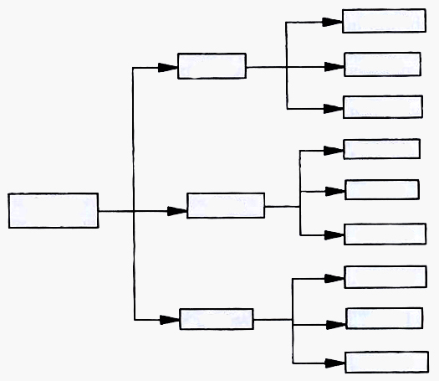

5. (3 pts) Comments within conversations, voiceovers that point out the importance of an activity, assets that can be read, and other types of hints are all examples of ________________________________________________________________________.

6. (3 pts) In what form of interactive media is doing the activity, rather than the story, the main appeal? In other words, if there’s going to be a story it has to integrate without interfering with this type of IM.

7. (3 pts) In one particular type of narrative, a lead character has a need or goal that they want to accomplish. Along the way they encounter obstacles that create conflicts. The conflicts build to an eventual climax and resolution. What narrative structure is being described?

8. (3 pts) Fill in the blank. A ___________________ of a computer game is similar to a linear film/TV treatment, providing the basic story line without extensive dialogue or calling shots.

9. (6 pts) Name 3 reasons storytelling is such a popular way to present information.

10. (3 pts) Identify the technique used in interactive dialogue that allows a player to choose characteristics like HAPPY, SAD, GRUMPY and the on-screen character performs the appropriate action. This technique maintains a level of surprise for the player and can be used for humor or shock value.

11. (5 pts) Refer to the diagram and name the narrative structure pictured. Identify each phase of the process.  Answer: ____________________ | 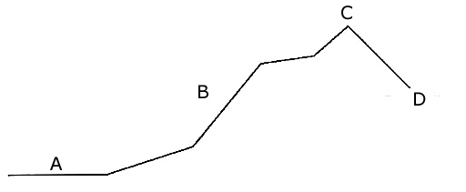

12. (3 pts) Fill in the blank. If a subject can be broken down into repeatable modules and potential users are spread over a wide area with ready Internet access, consider creating an ______________________.

13. (4 pts) What is the best way for a writer to create identification with one of his central characters?

14. (3 pts) In one particular type of narrative, the writer maintains the least control while the user enjoys maximum interactivity. What narrative structure is being described?
15. (4 pts) List the four major types of interactive games.

16. (4 pts) One of the major elements of interactive media is exposition. Define it.

17. (4 pts) Explain some techniques to make exposition effective in games.

18. (3 pts) The point in some games where “sub-paths” converge has the potential for awkwardness. Players might get confused or frustrated because they can’t advance. What is the name for such a condition?

19. (4 pts) What is the difference between scenes and sequences?

20. (4 pts) After a client approves an initial proposal, what are some of the points typically addressed in a design document?

21. (3 pts) In one particular type of narrative, the writer maintains some control while the user enjoys a high degree of interactivity. What narrative structure is being described?

22. (4 pts) What is the “critical path” and who is most likely to use it?

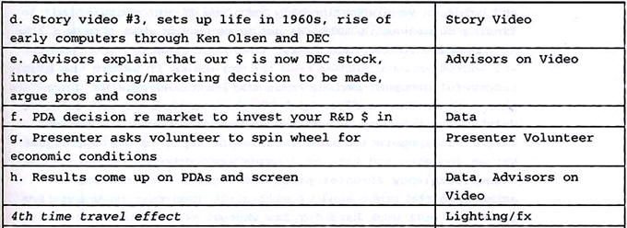
23. (4 pts) What is shown in the chart above? Don’t worry about where it came from; concentrate on explaining it’s purpose.

24. (8 pts) At some point most interactive writers wrestle with a decision about whether to accept contract versus permanent work. Explain some of the pros and cons that should be considered.

25. (6 pts) What are the two points of view in linear and interactive multimedia narratives? Which is most common?

