 | 1 ● Creating and Using a Database

Microsoft Office Access™ 2007 – a database management system. A database is a collection of data organized in a manner that allows access, retrieval and use of that data. Each database is a collection of tables, each of which contains information on a specific subject.

Functions of Access™:
- data entry and update – adding, changing & deleting data, including making mass changes in a single operation
- queries – ask complex questions about the data and receive instant answers
- forms – produce attractive & useful forms for viewing & updating data
- reports – report creation tools
- web support – save objects, reports & tables in HTML for viewing in a web browser

Records – the rows in the tables; contain info about people, products or events

Fields – the columns in the tables; contain a specific piece of information within a record

Unique Identifiers – unique numbers in a field; no two clients are assigned the same number. Also called primary key. Often these are the most common field in which the data will be sorted.

Design guidelines:
- identify the tables – a table is needed for each object identified
- determine primary keys – a unique identifier is needed for each table
- determine additional fields – typically there are many additional fields, each containing a type of data
- determine relationships among tables – if two tables are related include matching fields in both tables
- determine data types for fields – numbers, currency amounts, dates, text (see more on next page)
- identify & remove unwanted redundancy – don’t store data in more than one place
- determine a location for the database – it will be stored in a single file
Database Design Language (DBDL) is shorthand for showing the structure of a relational database. Each table has a name followed by parentheses, inside of which is a list of the fields in the table separated by commas. The primary key is underlined. Examples:

Product (Product Code, Description, On Hand, Price)

Client (Client Number, Client Name, Street, City, State, Postal Code, Amount Paid,
Current Due) [if there are enough columns, the second line should be indented]

The one-to-many relationship means that each row in the first table may be associated with many rows in the second table, but each row in the second table is associated with only one row in the first. The first table is called the “one” table and the second is called the “many.” Include the primary key from the “one” table as a field in the “many” table.

Naming tables & fields:
- names can be up to 64 characters in length
- names can contain letters, digits & spaces as well as most punctuation symbols
- names can’t contain periods (.), exclamation points (!), accent graves (`), or square brackets ([ ])
- the same name can not be used for two different fields in the same table
- “name” is a reserved word and the software won’t allow its use as a field name

The three most common Data Types:
- text – a maximum of 255 characters; numbers that won’t be used for arithmetic operations are usually designated as text (like phone numbers of zip codes)
- number – only numbers (+ or -) that can be used in arithmetic operations
- currency – only monetary data; values will appear with dollar signs, commas & two digits after the decimal point; can be used for arithmetic operations

[other Data Types are detailed in Table 1-1 on p.AC10]

Access™ 2007 features many of the components familiar to users of Microsoft Word and Excel® like the Office Button, Ribbon, Quick Access Toolbar, Mini toolbar and shortcut menus.

The Access work area is your primary workspace.
The Ribbon displays four top-level tabs: Home, Create, External Data, Database Tools. The tab currently displayed is the active tab.
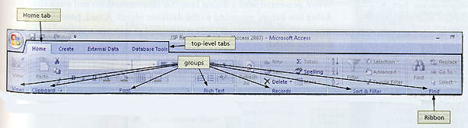
Access Ribbon including top-level tabs

To the left of the work area is the Navigation Pane; it contains a list of all the objects in the database.

Contextual tabs are displayed when you perform certain tasks or work with objects such as datasheets. The software determines when contextual tabs should appear or disappear.

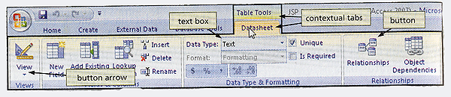
Contextual tabs

Dialog Box Launchers are available on the lower right of some groups on the Access™ Ribbon. When clicked they display a dialog box or task pane with additional options.

The Quick Access Toolbar is at the top left of the screen, right next to the Office Button. It typically contains icons that are shortcuts to the SAVE, UNDO or REDO commands.

One way Access™ is different from Word or Excel®:
As soon as you enter or modify a record and move to another one, the original is saved. In Excel®, for example, rows entered in a worksheet aren’t saved until the entire worksheet is saved.

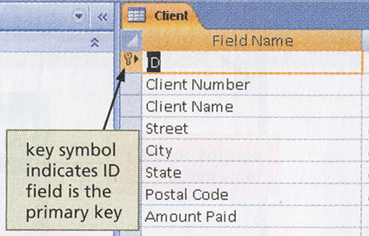 | Changing the Primary Key  The software automatically creates this in a new table. You can later change it to suit your needs by deleting the ID field that Access™ created. You then designate a new field for the primary key, but you must be in the Design view rather than Datasheet view. These are found in the extreme lower right corner of the screen.

When making changes to tables you must be in the datasheet view where the table is represented as a collection of rows and columns called a datasheet. In Datasheet view you can view many records at once (though if there are many fields only some might be visible at a time). In form view data is displayed in a form on the screen and you can usually see all the fields (but only for one record). A split form combines both a datasheet and a form, giving the advantage of both views.

To add records to a table that already contains data, you place the insertion point after the last data record before you enter the new data. Use the Navigation Buttons found near the lower left corner of the screen when a table is open. | 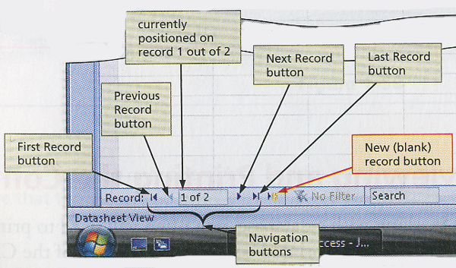

When opening a database you may encounter a Security Warning like this one.
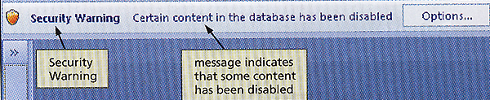
If so, click the Options button (shown) that displays the Microsoft Security Options dialog box. Then click the “Enable this content” button, and “OK.”

