 | 2 ● Querying a Database

Query – a question presented in such a way that a database management system could process or find answers from the database.

Microsoft Office Access™ 2007 contains a Simple Query Wizard if no restrictions, special order or calculations are required.

Query Design guidelines:
- identify fields – from the tables in the database
- identify restrictions – what conditions must be satisfied in order for records to be included in the results
- determine if special order is required – must the results appear in a specific order?
- determine if more than one table is required
- determine if special calculations are required – results of math operations are not typically stored in a database because they can easily be calculated when needed
- determine whether a crosstab query would be appropriate – if two different types of information need to be grouped one type will form row headings and the other will form column headings

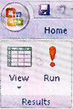  Create tab | Switch between views of a query by using the View button; (underneath the Ribbon on the Design tab at left); it alternates between Datasheet view and Design view.  Note that a View button appears on both the Home and Design tabs; use whichever is most convenient | 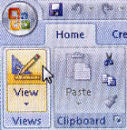  Home tab

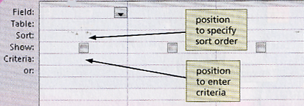 | Criterion – a condition that must be satisfied among the records included in a query. Enter criteria in the Criteria row of the design grid below the field name to which the criterion applies.
To enter numbers in a criterion, type the digits without a dollar sign or comma.

The design grid appears in the lower pane of the Access™ window. Add the fields you want included in the Field row of the grid. Only fields that appear in the design grid will be included in the query results.

Text data – data in a field whose data type is text as opposed to numbers or symbols.

Wildcards – symbols that represent any character or combination of characters. One common symbol is the asterisk (*) and it represents any collection of characters. Another wildcard symbol is the question mark (?) which represents any individual character.
Examples:
La* = the letters La followed by any other character(s)
200* = any year between 2000 & 2009 but not 2010 or higher
S?m = S followed by any single character followed by the letter, m (Sam, Sum)

Parameter query – one that prompts for specific input whenever it is used. Enter a parameter, rather than a specific value, as the criterion. Enclosing a value in a criterion in square brackets [ ] creates the parameter. The value in the brackets can not match the name of any field.
Example:
[Enter City]

Some queries lend themselves to regular use so you will want to save such queries. The query always use the data currently in the source table, so results of two queries can differ if changes to the data have been made.

Most queries assume you want exact match, or equality, data but other types of queries are possible. To make such queries you must employ the appropriate comparison operator.

> means greater than
< means less than
>= means greater than or equal to
<= means less than or equal to
NOT means not equal to

Property sheet – a window containing various properties of an object; to omit duplicates use it to change the Unique Values property from No to Yes.

Compound criterion – when the data you require must satisfy more than one requirement; there are two types
- AND criterion – each individual criterion must be true in order for the compound criterion to be true (example: find all clients in a specific city with a balance due); to combine criteria with AND, place the criteria on the same line in the design grid
- OR criterion – if either individual criterion is true the compound criterion is true (example: find all clients in a specific city or with a balance due); to combine criteria with OR, the criteria must be placed on separate lines of the design grid

To order the records in a query in a particular way, you sort them. The field (or fields) on which the records are sorted is called the sort key. When sorting more than one field the more important field is called the major key (or primary sort key); the less important field is called the minor key (or secondary sort key). If more than one sort key is specified, the one on the left will be the major key while the one on the right is the minor key.

Top-values query – allows you to show a limited number of results like a percentage …the highest (descending)…or lowest (ascending) values.

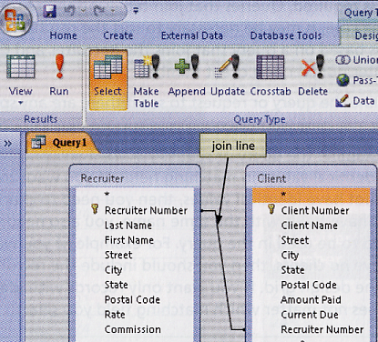 | Joining tables – done to find records in two tables that have identical values in matching fields. For example, both the Recruiter and Client tables in this chapter contain a field called “Recruiter Number.” [ see Figure 2-45 on page AC104]  After bringing field lists for each table to the upper pane of the query window (left) the software will draw a join line between the matching fields indicating they are related.

Calculated field – one that can be computed from other fields. When you determine a name for the calculated field you are creating an alias which becomes the column name when the query is run.
Example:
Total Amount:[Amount Paid]+[Current Due]

Calculated fields are usually populated using the Zoom command on the shortcut menu. Addition, subtraction, multiplication and division are all possible; parentheses are used to direct which calculation should be done first.

Microsoft Office Access™ 2007 supports several built-in statistics for group calculations including:

COUNT (count the number of records)
SUM (total)
AVG (average)
MAX (largest value)
MIN (smallest value)
STDEV (standard deviation)
VAR (variance)
FIRST (first value)
LAST (last value)

Aggregate function – when a mathematical function is performed against a group of records. It requires a Total row in the design grid even though one doesn’t normally appear there. To include it, click the TOTALS BUTTON on the Design tab.

Grouping – creating groups of records that share common characteristics; to activate, select Group By as the entry in the Total row for the field to be grouped.

Crosstab queries – calculate a statistic for data that is grouped by two different types of information. One type will appear down the side of the datasheet; the other will appear across the top.

Caution: several of the step-by-step instructions in this chapter specifically ask you to experiment with various commands, but not to save the results.

