 | 2 ● Formulas, Functions, Formatting  and Web Queries

Function – a prewritten formula built into Excel; you can assign a formula to a cell and Excel will calculate the result. Formulas can be in UPPER or lower case and there can be spaces before or after the indicated arithmetic (=D4 * E4 is the same as =d4*e4)

Order of operations – the process Excel uses when more than one arithmetic operator is involved in a formula, in this order:
- negation (-)
- percentages (%)
- exponentiations (^)
- multiplications (*)
- divisions (/)
- additions (+)
- subtractions (-)
Parentheses can be used to override the order of operations.

[pg. EX84: sample Requirements Document]

Chapter objective: to create two worksheets relative to The Silver Dollar Stock Club.

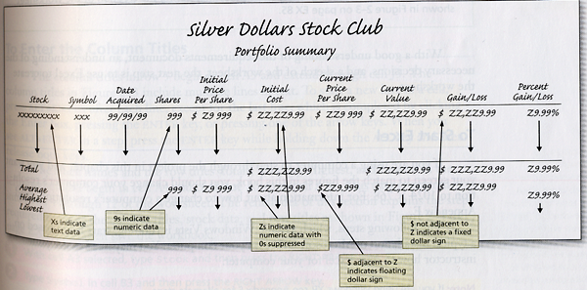
Figure 2-3
Wrapping text:
- right-click in the active cell
- click Format Cells on the shortcut menu
- click the Alignment Tab
- click Wrap text
- click OK

Use caution when entering year values. When you enter a value, Excel changes a two-digit value less than 30 to 20xx and a two-digit year of 30 and greater to 19xx. For safety, enter years in four-digit values.

Point mode – allows you to select cells for use in a formula by using the mouse.

 | Smart tags – data such as dates, financial symbols, people’s names; when active a small purple triangle, or smart tag indicator, appears in the cell. Move the insertion point over the smart tag indicator and the Smart Tag Actions button appears. To activate this feature you must use the AutoCorrect Options in the Excel Options dialog box:  - click Office button  - click Excel Options button  - click Proofing  - click AutoCorrect Options

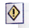 | When an error occurs in a formula, Excel displays the Trace Error button next to the cell and identifies the cell with the error by placing a green triangle in the upper left of the cell.

Functions – prewritten formulas to help you compute statistics. A function takes a value or values, performs an operation, and returns a result to the cell. The values you use with a function are called arguments. All functions begin with an equal sign and include the argument in parentheses after the function name. Example:

=AVERAGE(D4:D12)

function name: AVERAGE

argument: the range D4:D12

There are five ways to enter functions in Excel:
- the keyboard or mouse
- the Insert Function box in the formula bar
- the Sum menu
- the AutoSum command on the Formulas tab of the Ribbon
- the Name box area in the formula bar

Range Finder – a tool to check which cells are referenced in the formula assigned to the active cell

Accounting number format – the way Excel displays numbers with a dollar sign to the left, and commas every three positions to the left of the decimal point. A fixed dollar sign displays to the far left of a cell often with spaces between it and the first digit ($ 12,345.00). A floating dollar sign appears immediately to the left of the first digit ($12,345.00); this is commonly used in the currency style format. The comma style format displays numbers with commas but no dollar signs (12,345.00).

Conditional formatting – appears only when the value in a cell meets specified conditions. A condition is made up of two values and a relational operator; it must be true or false for each cell in the range. If the condition is true, Excel displays the formatting. If the condition is false, Excel suppresses the formatting.

Print orientation:
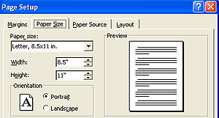 | 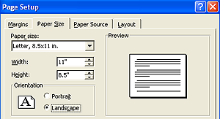

Values version of the worksheet – shows the results of formulas rather than actual formulas

Formulas version of the worksheet – shows the actual formulas rather than resulting values (toggle between the versions by holding CTRL and ACCENT MARK (`) located to the left of the digit 1. [p.EX136]

Debugging – the process of finding & correcting errors in the worksheet

Excel can import external data from the Internet using a web query. The data is imported into a worksheet. Three web queries are available:
- investor currency rates
- investor major indices
- investor stock quotes

