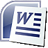 | 2 • Creating a Research Paper

Research paper – a document to communicate the results of research findings.

Two popular documentation styles:
- American Psychological Association (APA)
- Modern Language Association of America (MLA) – the style used in this chapter
- each page contains a page number
- first page contains student name, course #, date in block at top left beginning one inch from top of page
- title should be centered
- continue with thesis statement, supporting details & conclusion
- final page contains a detailed, alphabetical list of research sources
- double-space all pages
- one-inch top, bottom, left & right margins
- indent first word of each paragraph by one-half inch
- place page # at right margin of each page, one-half inch from top margin
- on each page precede the page # with your last name
- place author references in parentheses [ ( ) ] with page #

General guidelines for writing a research paper:
- select topic
- conduct research & take notes; list details about sources (title, author, publication, date, page, etc.)
- avoid plagiarism (if you copy information, place it inside quotation marks [“ ”] and identify the source)
- organize ideas into an outline
- write first draft, referencing sources
- create list of sources
- proofread & revise as necessary

The MLA documentation style uses in-text parenthetical citations instead of noting each source at the bottom of the page or at the end of the paper. Optional explanatory notes elaborate on points discussed in the document. Note text can be any length or format and the software automatically numbers the notes sequentially. Superscript raised numbers signal to the reader that such a note exists ¹.

Footnotes – explanatory notes at the bottom of the page

Endnotes – explanatory notes at the end of the paper

Sample Footnote
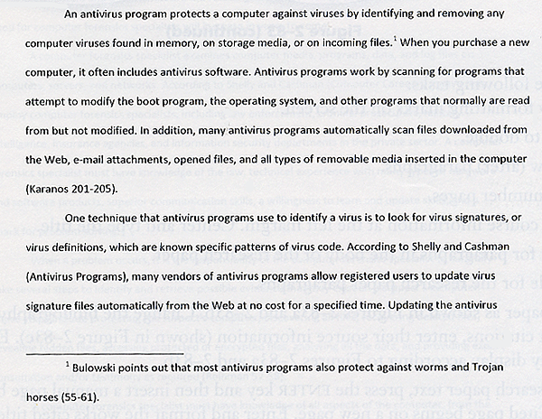

Sample Endnotes

Chapter 1 - Manes, Trains and Planes

¹ Jeremiah Milbank, Jr., The First Century of Flight in America, p.43.
² “Fourth of July in Manchester – Balloon Ascension,” Dollar Weekly Mirror, June 28, 1856, p.2.
³ “Ballooning,” Scientific American, July 26, 1856, p.368.
⁴ “The Balloon Ascension,” Mirror and American, July 7, 1860, p.unknown.
⁵ “Minor Items,” Mirror and American, June 3, 1875, p.4.
⁶ Jeremiah Milbank, Jr., Op. Cit., p.139.
⁷ Cecil Woodham-Smith, The Great Hunger – Ireland 1945–1849, p.206.
⁸ “Bird Man Atwood Flies to Manchester,” Manchester Daily Mirror and American, June 20, 1911, p.1.
⁹ Ibid.
¹⁰ “Birdman Atwood Flew Over City, The Manchester Union, June 20, 1911, p.1.
The MLA style uses the term works cited to refer to the bibliographic list of sources at the end of a paper. They should appear on a separate numbered page with the title an inch from the top margin, centered and double-spaced. Subsequent lines of text for an entry should be indented one-half inch from the left margin.

Sample Works Cited
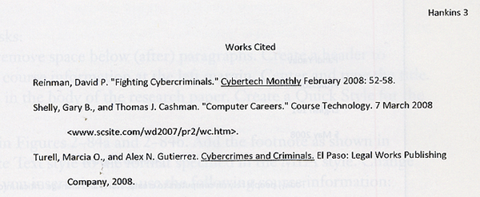

Line spacing – the amount of vertical space between lines of a paragraph

Paragraph spacing – the amount of space above and below a paragraph

Header – text & graphics that print at the top of each page in a document

Footer – text & graphics that print at the bottom of each page

Click and Type is a tool in Microsoft® Word 2007 that allows you to format and enter text, graphics and other items. Double-click a blank area of the document window and Word automatically format the item according to the location you double-clicked.

Shortcut keys – keyboard key commands to format text as you type it. These usually utilize the CTRL or SHIFT keys (see lengthy list on p.WD86; bottom left of page gives instruction for how to print a complete list of shortcut commands).

A horizontal ruler displays at top edge of a document window just below the ribbon, while a vertical ruler displays along the left edge. The VIEW RULER button is at the extreme right of the screen atop the scroll bar.

The First Line Indent marker is the top triangle at the 0 inches mark on the ruler. It allows you to indent only the first line of a paragraph. The Left Indent marker allows you to change the entire left margin.

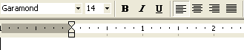 | The Hanging Indent marker is the bottom triangle at the 0 inches mark on the ruler.

AutoCorrect is a feature of Microsoft® Word 2007 that automatically corrects typing, spelling, capitalization or grammar errors as you type them. This feature can be turned off (instructions on p.WD94).

Automatic page breaks, also called soft page breaks, are inserted when the software determines the text has filled one page according to the designated parameters of margins, paper size, font size and line spacing. This function is referred to as background pagination.

Manual page breaks, or hard page breaks, are forced into a document at a specific location.

Drag-and-drop editing allows you to drag selected text and/or graphics to a new location and insert, or drop, them there. Cutting involves moving selected items from a document to the Clipboard, a temporary Windows storage area. Pasting is the process of copying an item from the Clipboard into a document at the location of the insertion point.

Synonym – a word similar in meaning to a highlighted word

Thesaurus – a book of synonyms

